Design plan for happy valley Kennel Web Site

Philip Dumaresq

November 2, 2015

Heritage College - 2015

Purpose:

The purpose of the happy valley kennel site is to inform people who are looking for a place to let their dogs stay while they go away of their business. They also want to have people rate them and let others know about their business so they can have both new customers and old ones to come back. The final goal is to attract both new and old customers to using their services.

Audience:

The target audience of this site is dog owners in general. People who are middle aged and going on a family vacation or young couples who need a place to keep their dogs while leaving town to visit their families, go on road trips or go travelling. Because of this broad target audience, the site should be able to appeal to all sorts of people. The older people might not want as many graphics, but younger people might prefer to relate to them more through pictures, so the site should contain a balance between the two. The people who will be dropping off their dogs here will also be wealthier because they can afford to leave their dogs here instead of getting a friend or family member to watch them. The kennel is also located in Gatineau and will be attracting people from that area, so the site should also have information in French for francophone people.

Content:

The site is going to contain all of the information that dog owners have to have before paying them to watch their dogs while they’re gone as well as encourage dog owners to choose their site over another dog kennel.

The site has to contain the hours that you can go and drop off your dogs and how much it costs to leave your dog with them. Because their dogs will likely be there for upwards of a few weeks sometimes, people want to know who will be taking care of their dogs, so there’s a page giving you a brief biography of all of the staff members for the kennel. There should also be testimonials from new users and longtime clients because it’s important for people who want to drop their dogs off there what other people think of their business. There should also be a page that has links to maybe other services that the company offers besides a dog kennel. There should be a page that people can go to so that they can contact the company (an inquiries page and a contact page can be put into one page, there’s no need for two separate pages). The contact page should have an email address, a phone number or two, and its location on a map with the address.

Structure:

The site is organized hierarchically. There’s no subpages at the moment, but you can move to any of the main pages from page on the site. The site has a left panel for navigation that includes all of the main page. There’s also a site map at the bottom of the page. Mobile site will have a hamburger for navigation. The site logo has a plain brown background with paw prints across the bottom and curling up the left hand site and has Happy Valley Kennel written in black bubbly font in the middle.

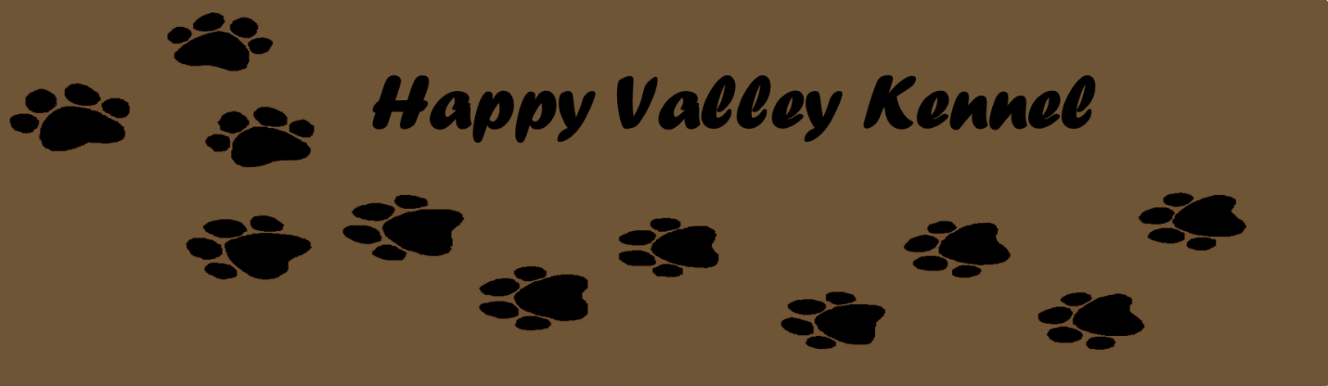

Wireframe:

Main site:

The main site contains a left and right panel. The left panel contains navigation and the right panel contains the banner and the main content of the site. At the bottom of the page (not inside one of the panels) is a footer containing a site map.

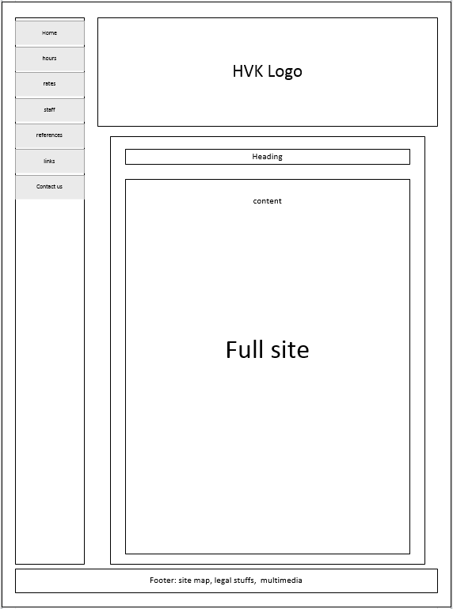

Mobile page:

The mobile page contains only one column. At the top, there’s the banner along with a hamburger for the navigation. Under the banner, there’s a panel holding all of the content. Under all of the content, there will be a hyperlink leading back up to the top of the page. Under there, there will be a smaller site map.

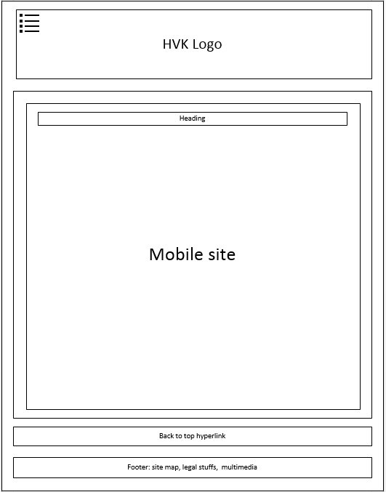

Content

Mobile site